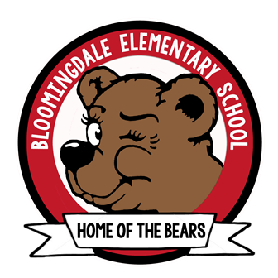 PRE-K Supply List
A change of clothes including underclothes and socks (Please label all items)
Crib fitted sheet (cover for mat)
Blanket or towel (cover for nap)

Snack daily (1 item to eat and/or 1 item to drink)

Uniform policy
- Solid khaki or solid black shorts, skirts, skorts, jumpers. Capri pants/slacks. Skirts, skorts, jumpers and shorts must be no shorter than three inches above the knee. (No knit pants, jogging or cargo pants; no zippers or pockets on the pant legs.)
- Uniform must be worn and belted at the natural waist and made of standard uniform material. (black, brown, or navy)
- Solid white or red tops. Tops may be polo style shirts, collared blouses or turtlenecks. All shirts must be tucked.
- All shoes must be enclosed and tied properly.
- Socks are white, black, or navy.
- Tights should be either red or white.
- Solid white or red sweatshirts, vests, or sweaters may be worn over the uniform shirts.

Clear or mesh backpack (no wheels-please label with your child’s name)
Optional Wish List Items
2-Boxes of Kleenex
1-Bottle of liquid soap
1-Box of quart ziplock bags
1-Box gallon ziplock bags
1-Box of baby wipes
2-Tubs of Clorox wipes
1-headphones (inexpensive)
1-Nap mat

